AI 3D Content Correction & Direction

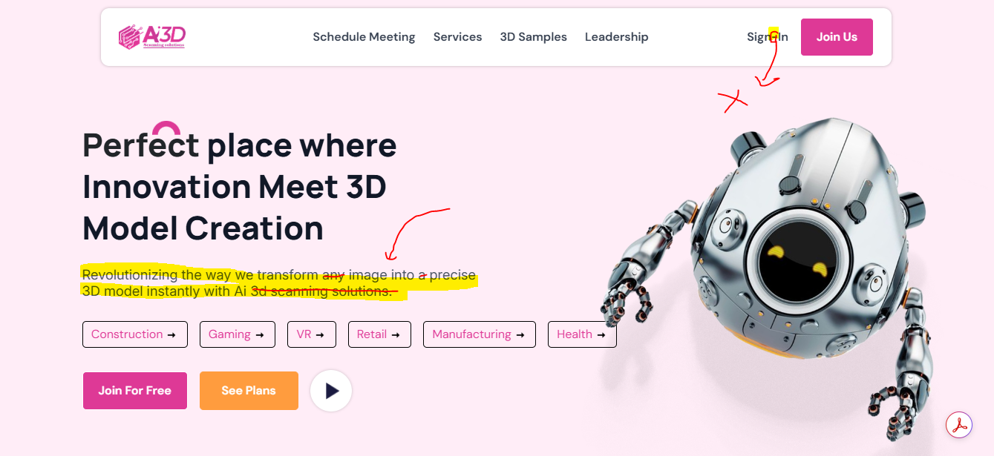

Tagline change : AI-powered platform for live 3D model generation, editing, and collaboration - no expensive hardware needed.

2:

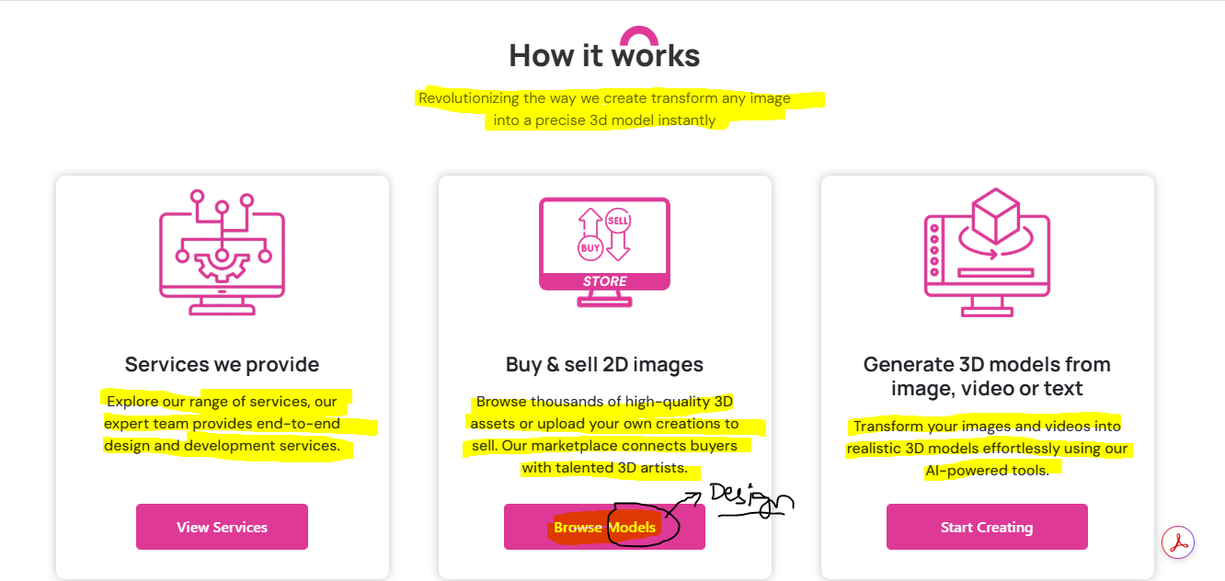

"How it works"
- Change :
How It Works - Transform Any 2D data into a High-Precision 3D Model in minutes

Card 1: Services we provide
- Change:
Explore our full range of AI and software services - from concept to deployment, our expert team delivers cutting-edge design, development, and customization solutions for your business.

Card 2: Buy & sell 2D Designs
- Change:
Buy & Sell Assets and 2D Designs - Browse thousands of high quality assets or upload your own creations to sell. Our marketplace connects global buyers with top tier creators and 3D artists.

Card 3: Generate 3D models from image, video or text
- Change:
Create stunning, photorealistic 3D models from images, videos, or text prompts - all powered by our AI engine. No hardware, no manual modeling, just instant results.

3:

OUR SERVICES SECTION SHOWN NOT NEEDED REMOVE AS GUIDED… B2B part suggestions here

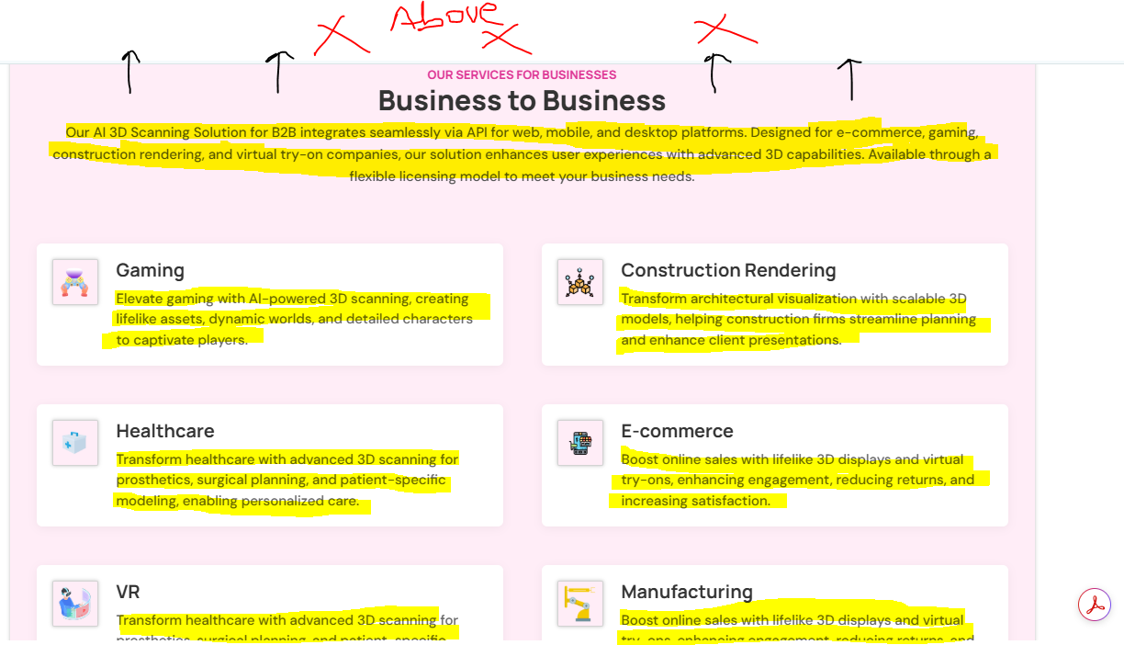
Header & Intro
AI3D integrates seamlessly into your existing web, mobile, or desktop ecosystem through robust APIs. From e-commerce and gaming to construction, healthcare, and manufacturing - our AI converts 2D images, videos, and text into lifelike, interactive 3D models in seconds. Flexible licensing and deployment options ensure a perfect fit for your business goals.

Service Cards

Gaming
Accelerate game development with instant AI powered 3D scanning - create lifelike assets, immersive worlds and high detail characters faster and at lower cost.

Construction Rendering
Streamline architectural visualization with AI generated, scalable 3D models - perfect for planning, collaboration, and creating stunning client presentations that win projects.

Healthcare
Enable precision healthcare with advanced 3D scanning - from custom prosthetics to surgical planning and patient specific anatomical modeling, ensuring accuracy and better outcomes.

E-commerce
Increase online conversions with realistic 3D product displays and AR try-ons - enhancing engagement, reducing returns, and improving customer trust.

VR
Fuel next-gen VR experiences with AI-generated 3D environments, realistic avatars, and immersive assets - ideal for gaming, training, and simulations.

Manufacturing
Optimize manufacturing workflows with instant 3D scanning for prototyping, digital twins, and product visualization - reducing design cycles and speeding up time to market.

4:
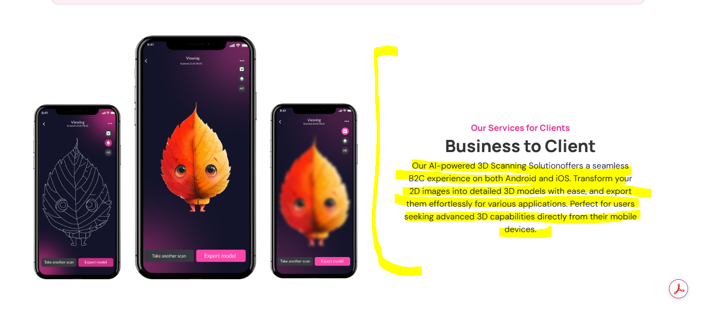
Experience the power of AI3D anywhere - on Android, iOS, and Web. Our AI-powered 3D Scanning platform lets you instantly transform 2D images into high-precision, photorealistic 3D models without the need for complex tools or technical skills.
Create, customize, and export your models effortlessly for gaming, AR/VR, product design, 3D printing, or personal projects.
Key Highlights:
- Instant AI Conversion – Turn any image into a 3D model in seconds.
- Cross-Platform Access – Work from mobile or web and keep your creations synced.
- Easy Editing Tools – Customize models with intuitive controls.
- Export Anywhere – Download in multiple formats for your needs.

5:
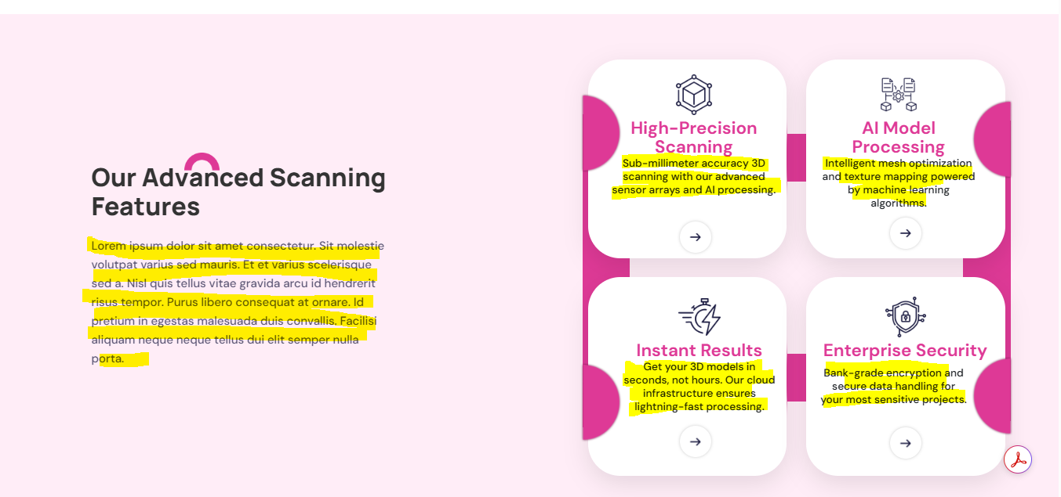

Our Advanced Scanning Features
AI3D combines cutting-edge AI algorithms with powerful cloud infrastructure to deliver studio-quality 3D scanning that’s fast, accurate, and secure. Whether you’re creating for gaming, e-commerce, design, or enterprise use, our features ensure your results are top-tier and ready for production.

High-Precision Scanning
Capture every detail with sub-millimeter accuracy. Our AI-driven scanning technology ensures lifelike, photorealistic results using advanced sensor algorithms and deep learning enhancements.

AI Model Processing
Automatically optimize your 3D models with intelligent mesh generation, texture mapping, and polygon reduction - balancing visual quality with performance for any platform.

Instant Results
No more waiting hours for rendering. Our scalable cloud infrastructure processes images, videos, or text prompts into ready to use 3D models within minutes.

Enterprise Grade Security
Your data is protected with bank-grade encryption, secure cloud storage, and compliance with global data protection standards - ensuring confidentiality at every stage.
6:
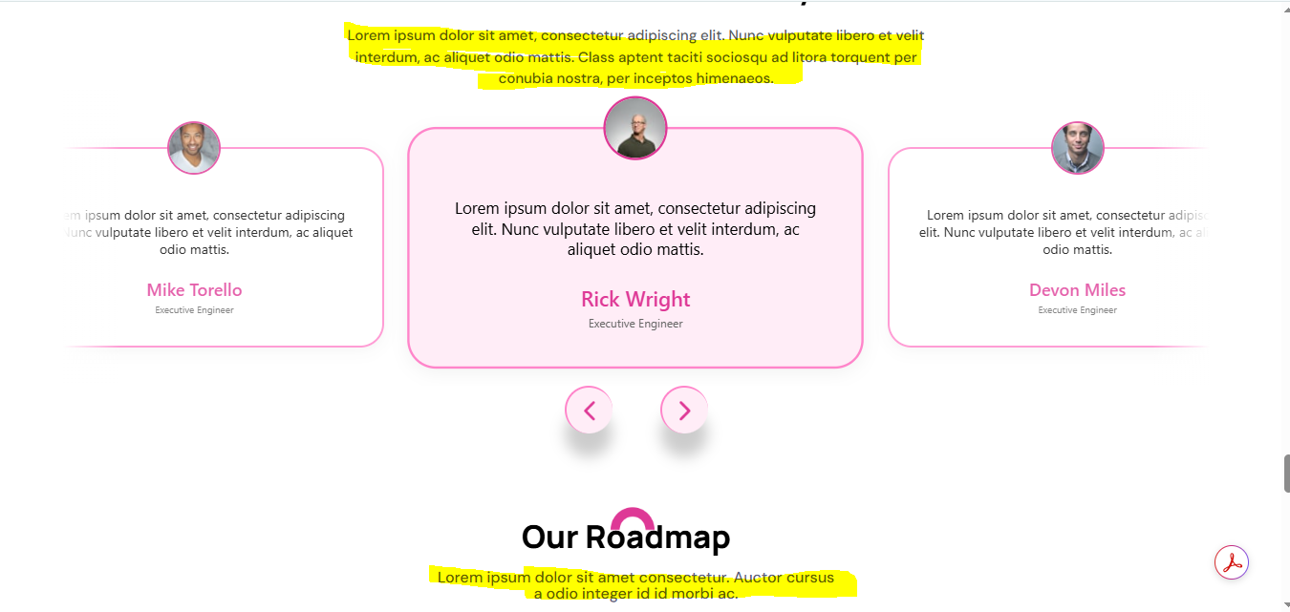

Testimonials

What Our Customers Say
From gaming and e-commerce to healthcare, manufacturing, and construction, our clients trust AI3D Scanning Solutions to deliver high-precision 3D models, faster workflows, and cost-efficient results.
Each partnership is a story of innovation

Our Roadmap
We are building AI3D Scanning Solutions into a complete, industry-ready platform through a carefully planned development journey.

1. Initial Development
Laying the foundation for our AI engine, mobile & web applications, and core scanning modules. This stage focuses on research, prototyping, and infrastructure setup.

2. Development Mode Release
Launching the first functional version of our AI-powered scanning platform for internal testing and selected early adopters. Continuous iteration based on feedback.

3. Beta Release
Exclusive access for our B2B and B2C waitlist clients, allowing them to test features, provide input, and help shape the final product.

4. Public Release
Full-scale launch for general customers, enterprises, and partners—delivering our complete suite of scanning, editing, and 3D asset management features.

7:

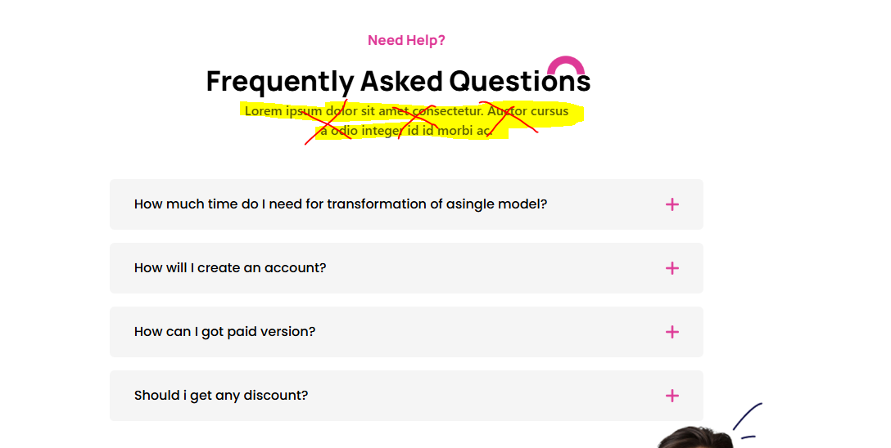

Frequently Asked Questions
How long does it take to transform a single model?
With our AI powered processing, most 3D models are generated in seconds to a few minutes, depending on complexity and resolution settings.

How do I create an account?
Simply click "Sign Up" on our website or mobile app, enter your details, and verify your email. You can start with a free trial immediately.

How can I upgrade to the paid version?
You can upgrade anytime from your account dashboard by selecting a subscription plan and making a secure online payment.
Do you offer discounts?
Yes-discounts are available for annual subscriptions, educational institutions, and bulk enterprise packages. Contact our sales team for details.

8:
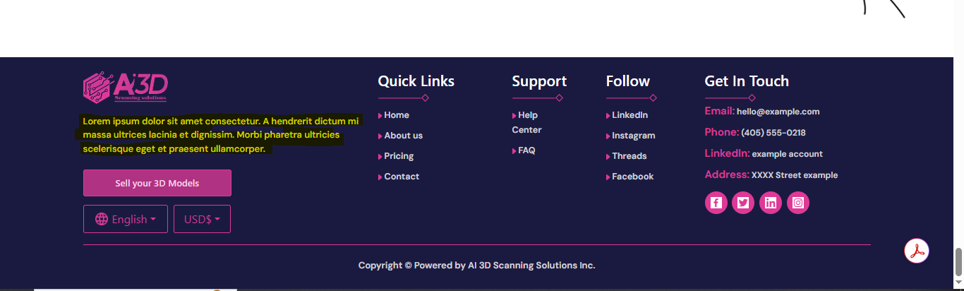
AI 3D Scanning Solutions transforms photos, videos, and real-world objects into high-precision 3D models instantly and without expensive hardware. Our platform offers creation, editing, and a vast 3D content library, all powered by cutting edge AI. From individuals to enterprises, we make 3D accessible, scalable, and secure.

9: SERVICES PAGE CONTENT WHEN REDIRECT

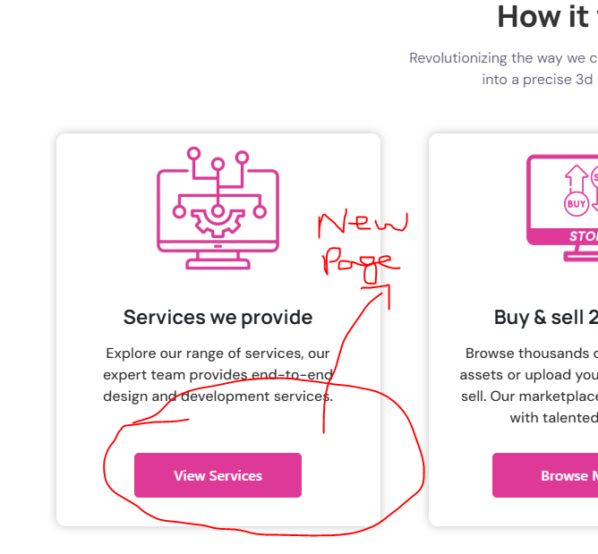

Our Full Range of AI & Software Services
From concept to deployment, AI 3D Scanning Solutions delivers end-to-end technology services that combine innovation, precision, and scalability. Our expert team transforms ideas into reality with cutting-edge design, development, and customization solutions tailored to your business goals.
We don’t just build, we partner with you to create future ready products that drive growth and efficiency.

Our Core Services

1. AI Development & Solutions
- Custom AI model design and training
- Machine learning & deep learning integrations
- Computer vision and 3D data processing
- Natural language processing (NLP) solutions

2. Web Development
- Responsive, high-performance websites
- Full-stack development (React, Node.js, Laravel, etc.)
- API integration & automation
- Scalable cloud-based web apps

3. Creative Media
- Brand identity design
- UI/UX design for web & mobile
- Motion graphics and 3D animations
- Marketing visuals & campaign assets

4. Flutter App Development
- Cross-platform mobile apps for iOS & Android
- Single codebase, high-quality native performance
- Feature-rich, scalable, and secure applications

5. Desktop App Development
- Windows, macOS, and Linux desktop solutions
- Custom tools and enterprise-grade software
- Offline and online hybrid capabilities
6. Business Development & Consulting
- Go-to-market strategies
- B2B and B2C sales enablement
- Partnership & ecosystem building
- Scaling roadmaps and investor readiness

WIRE FRAME FOR REFERENCE
